Aim: To study Web Applications, Native Applications, and Progressive Web Applications (PWA) and understand their features, advantages, and differences.

Theory:

Q1. What is a Web Application? (Explain how web applications work and give examples)
A web application is software you use through a web browser (like Chrome or Safari) without installing it on your computer.
Working:
You type a web address → Browser sends a request to a server → Server processes the request and sends back the page → Your browser displays it so you can interact.
Examples: Gmail, Google Docs, Facebook, Online shopping sites.

Q2. List and explain the advantages of Web Applications.
- No installation: Open a browser and use it immediately.
- Works anywhere: Accessible from any device (phone, tablet, computer) with internet.
- Cross-platform: Works on Windows, Mac, Linux, etc. without separate versions.

Q3. What is a Native Application? (Explain how native applications are different from web applications)
A native app is software built specifically for one platform (like Android or iOS) and must be installed from an app store.
Difference from Web Apps:
- Installation: Native apps need downloading/installing; web apps just need a browser.
- Platform-specific: Native apps are built separately for Android and iOS; web apps work on both.
- Hardware access: Native apps can easily use camera, GPS, etc.; web apps have limited access.

Q4. List and explain the advantages of Native Applications.
- Fast performance: Optimized for the specific device.
- Hardware access: Can use camera, microphone, GPS, notifications easily.
- Available in app stores: Easy to find and install.

Q5. What is a Progressive Web Application (PWA)? (Explain how it combines features of web and native applications)
A PWA is a website that behaves like a native app. It's built with web technology but can be installed on your device, work offline, and send notifications.
Combines features:
- Like web apps: Easy to update, accessible via link.
- Like native apps: Can be installed, works offline, loads quickly.

Q6. Explain the architecture of a Progressive Web Application.
Components:
- Service Worker: Background script that manages offline functionality and caching.
- Server: Stores the main app files and data, sends updates when online.
- Cache storage: Stores app files locally so they load instantly.
- Operation:
  - Online: Gets fresh data from server, updates cache.
  - Offline: Loads from cache, works without internet.

Q7. What is a Service Worker and why is it important for PWAs?
A Service Worker is a script that runs in the background, separate from the webpage.
Importance:
- Enables offline usage by caching files.
- Handles push notifications.
- Speeds up loading by serving cached content.
- Syncs data when internet returns.

Q8. To observe and understand how different types of applications work in real-world scenarios.
Desktop View:
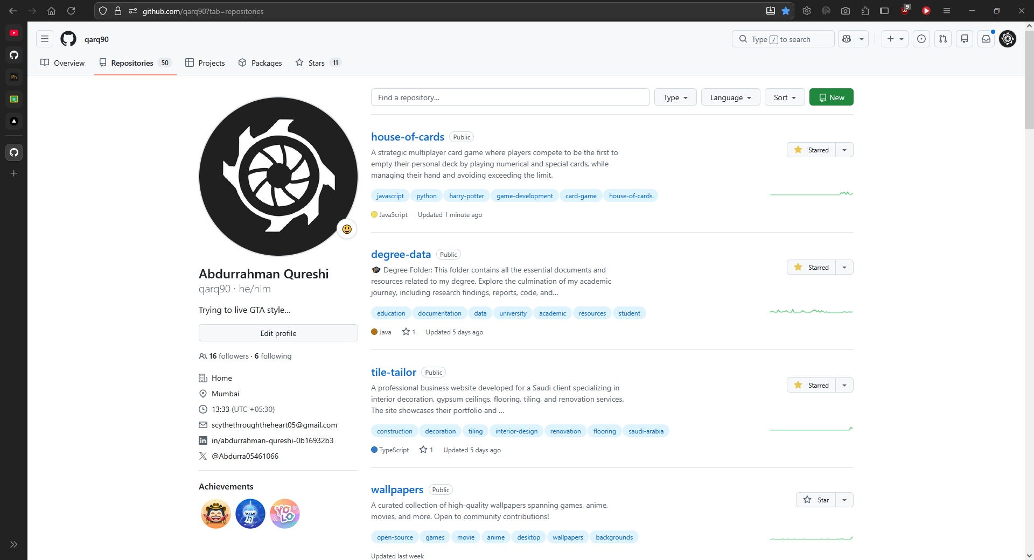
Phone View:
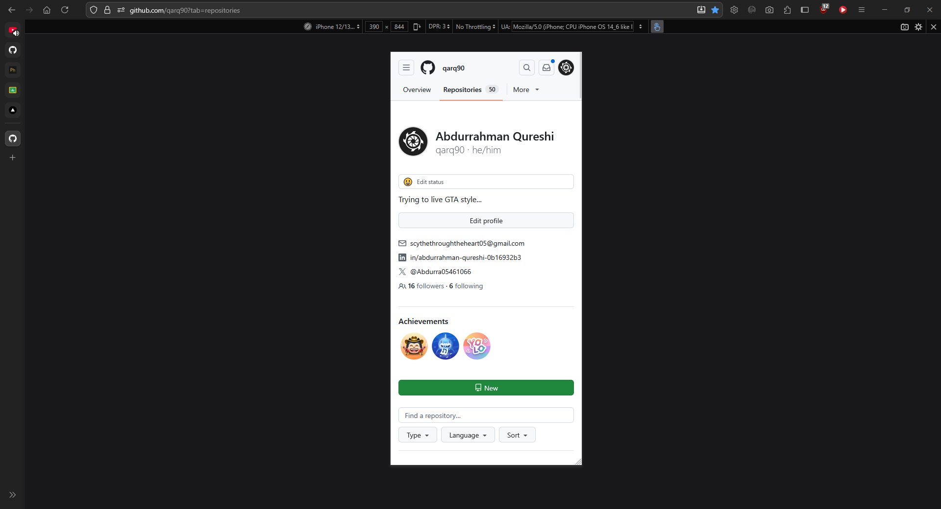

Tablet View:
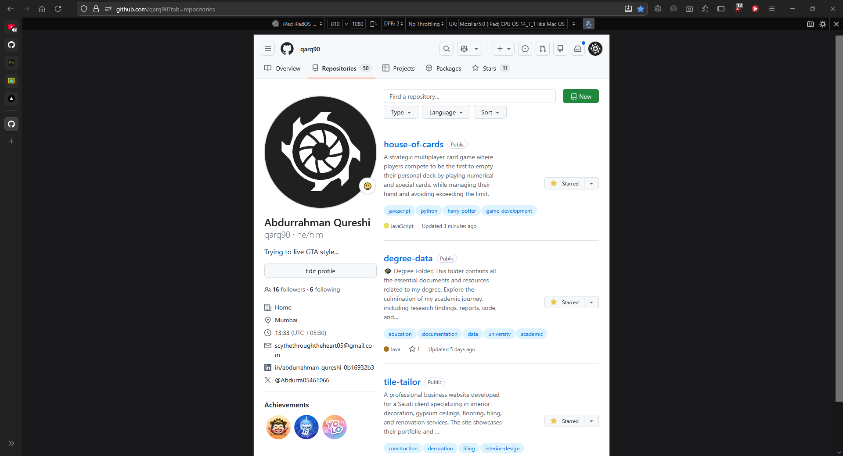

Conclusion
Studied and implemented Web, Native, and Progressive Web Applications by developing cross-platform apps with cloud backend integration to analyze their architecture, features, and real-time data management capabilities.

